Project Model
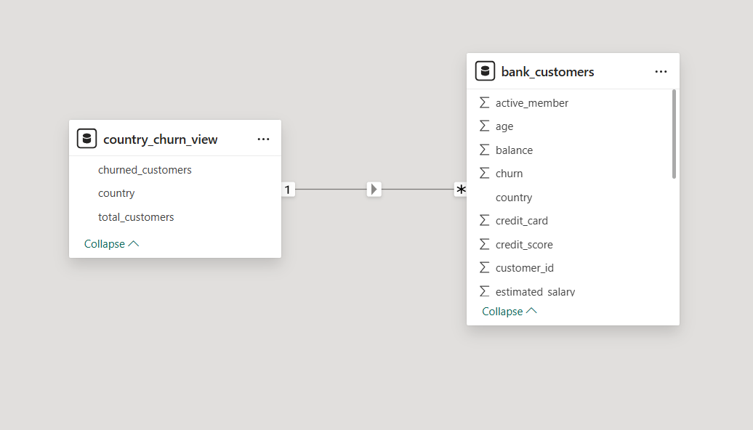

Churn Analysis Dashboard
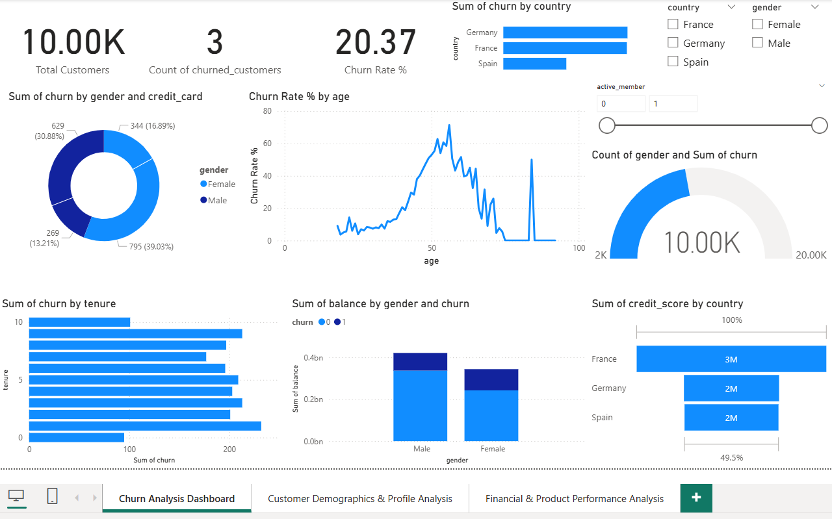
Dashboard Overview
The Churn Analysis Dashboard provides a comprehensive view of customer churn behavior across different demographic, geographic, and behavioral dimensions. The purpose of this dashboard is to identify which customers are leaving the bank, why they are leaving, and which segments are at the highest risk.
This dashboard helps decision-makers quickly understand churn trends and take proactive retention actions.
Key Performance Indicators (KPIs)
1. Total Customers – 10,000
This KPI shows the total number of customers included in the analysis. It represents the full customer base used for churn evaluation.
2. Count of Churned Customers
This indicator displays the total number of customers who have exited the bank (customers with churn = 1).
3. Churn Rate (%) – 20.37%
This KPI shows the percentage of customers who have churned out of the total customer base.
A churn rate of 20.37% indicates that roughly 1 out of every 5 customers has left the bank, which is a significant concern and requires targeted retention strategies.
Visual Insights
4. Churn by Country
This bar chart compares churned customers across different countries.
Key Insight:
- Germany has the highest number of churned customers
- France follows closely
- Spain shows relatively lower churn
This indicates that geographic factors may be influencing customer dissatisfaction and retention.
5. Churn by Gender and Credit Card Ownership
This donut chart shows churn distribution based on gender and credit card status.
Key Insight:
- Male customers contribute a higher portion of churn compared to females
- Customers without credit cards show higher churn, indicating lower product engagement
This suggests that cross-selling financial products may improve customer retention.
6. Churn Rate (%) by Age
This line chart shows how churn rate varies across different age groups.
Key Insight:
- Churn rate increases significantly for customers aged 40–60
- Younger customers have relatively lower churn
- Churn drops after senior age groups
This suggests that middle-aged customers are the most at-risk group and should be a primary target for retention efforts.
7. Active vs Non-Active Member Filter
The active member slicer allows users to analyze churn for:
- Active customers
- Non-active customers
Key Insight:
- Non-active customers consistently show higher churn rates
- Customer engagement plays a critical role in retention
8. Churn by Tenure
This horizontal bar chart shows churn distribution based on customer tenure (years with the bank).
Key Insight:
- Customers with short to mid tenure are more likely to churn
- Long-term customers show lower churn
This suggests that early-stage customer engagement is crucial to long-term retention.
9. Balance by Gender and Churn
This stacked bar chart compares total account balance by gender and churn status.
Key Insight:
- Male customers hold a higher total balance
- Churned customers still hold significant balances, indicating potential revenue loss
Retaining high-balance customers should be a strategic priority.
10. Credit Score by Country
This chart shows total credit score contribution by country.
Key Insight:
- France has the highest total credit score
- Germany and Spain follow
This helps understand customer credit quality across regions and supports country-specific credit policies.
Dashboard Interactivity
The dashboard includes interactive filters:
- Country
- Gender
- Active member status
These filters allow users to drill down into specific customer segments and analyze churn behavior dynamically.
Business Insights Summary
- Customer churn is significantly influenced by age, activity level, and geography
- Non-active and middle-aged customers have the highest churn risk
- Customers with fewer products and lower engagement are more likely to leave
- High-balance churned customers represent a major revenue loss opportunity

Customer Demographics & Profile Analysis Dashboard
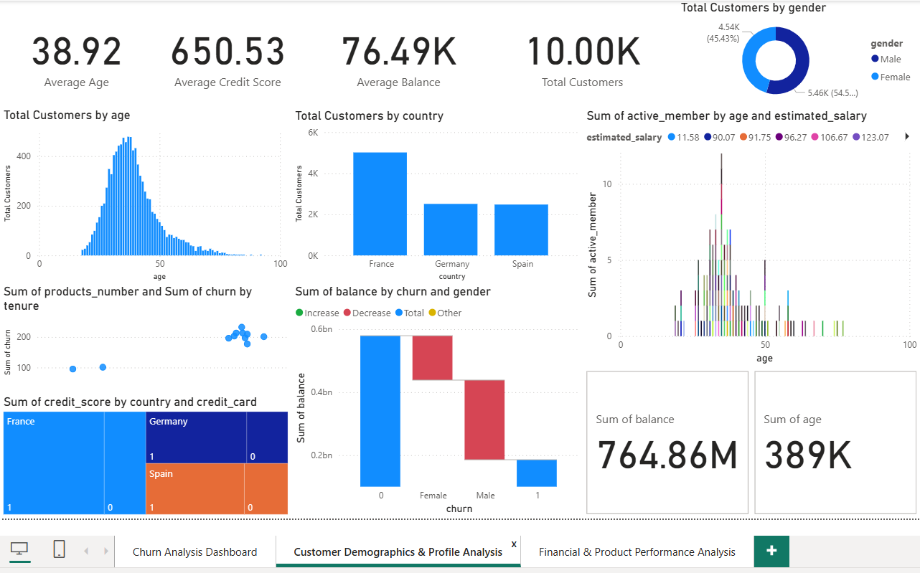
Dashboard Overview
The Customer Demographics & Profile Analysis Dashboard provides a detailed overview of the bank’s customer base by analyzing age, gender, country, credit score, balance, salary, and activity level.
The purpose of this dashboard is to understand who the customers are, how they are distributed demographically, and how their financial behavior varies across different segments.
This dashboard supports customer segmentation, targeted marketing, and personalized banking strategies.
Key Performance Indicators (KPIs)
1. Average Age – 38.92 Years
This KPI shows the average age of customers in the dataset.
It indicates that the bank’s customer base is primarily composed of working-age adults.
2. Average Credit Score – 650.53
This represents the overall credit quality of customers.
A credit score around 650 indicates a moderate to good credit profile, suitable for loans and credit products.
3. Average Balance – 76.49K
This KPI shows the average account balance per customer.
It reflects the financial strength and deposit value of the customer base.
4. Total Customers – 10,000
This confirms the total number of customers analyzed in this dashboard.
Visual Insights
5. Total Customers by Gender
This donut chart shows gender distribution among customers.
Key Insight:
- Female customers slightly outnumber male customers
- The customer base is fairly balanced by gender
This helps in designing gender-neutral or targeted banking products.
6. Total Customers by Age
This histogram displays customer distribution across different age groups.
Key Insight:
- Majority of customers fall between 30 and 50 years
- Very few customers are in extreme age groups (below 20 or above 70)
This confirms that the bank’s core customers are middle-aged professionals.
7. Total Customers by Country
This bar chart shows customer distribution by country.
Key Insight:
- France has the largest customer base
- Germany and Spain have similar but smaller customer counts
This highlights market concentration and regional customer presence.
8. Active Members by Age and Estimated Salary
This visualization shows how customer activity varies by age and salary levels.
Key Insight:
- Customers aged 30–50 with higher salaries are more active
- Younger and older customers show lower activity levels
This suggests that income level and life stage influence customer engagement.
9. Products and Churn by Tenure
This scatter chart compares:
- Number of products owned
- Customer churn
- Customer tenure
Key Insight:
- Customers with more products and longer tenure tend to churn less
- Customers with fewer products are more likely to leave
This reinforces the importance of cross-selling and customer loyalty programs.
10. Balance by Churn and Gender
This waterfall chart shows how account balance changes by churn status and gender.
Key Insight:
- Non-churned customers contribute the majority of total balance
- Churned male and female customers represent a significant balance loss
- Male customers generally hold higher balances than female customers
Retaining high-balance customers is critical for profitability.
11. Credit Score by Country and Credit Card Ownership
This treemap shows credit score distribution by country and credit card status.
Key Insight:
- Customers with credit cards generally have higher credit scores
- France shows the strongest credit score contribution
- Credit card ownership is associated with better customer quality
Summary KPIs at the Bottom
Total Balance – 764.86M
Represents the total deposits held by all customers.
Total Age – 389K
Represents the cumulative age of all customers, used for statistical aggregation.
Business Insights Summary
- The bank’s core customers are middle-aged, working professionals
- France is the strongest customer market
- Higher salary and credit score customers are more active
- Customers with more products and higher engagement are less likely to churn
- Credit card ownership is a strong indicator of customer value

Financial & Product Performance Analysis Dashboard
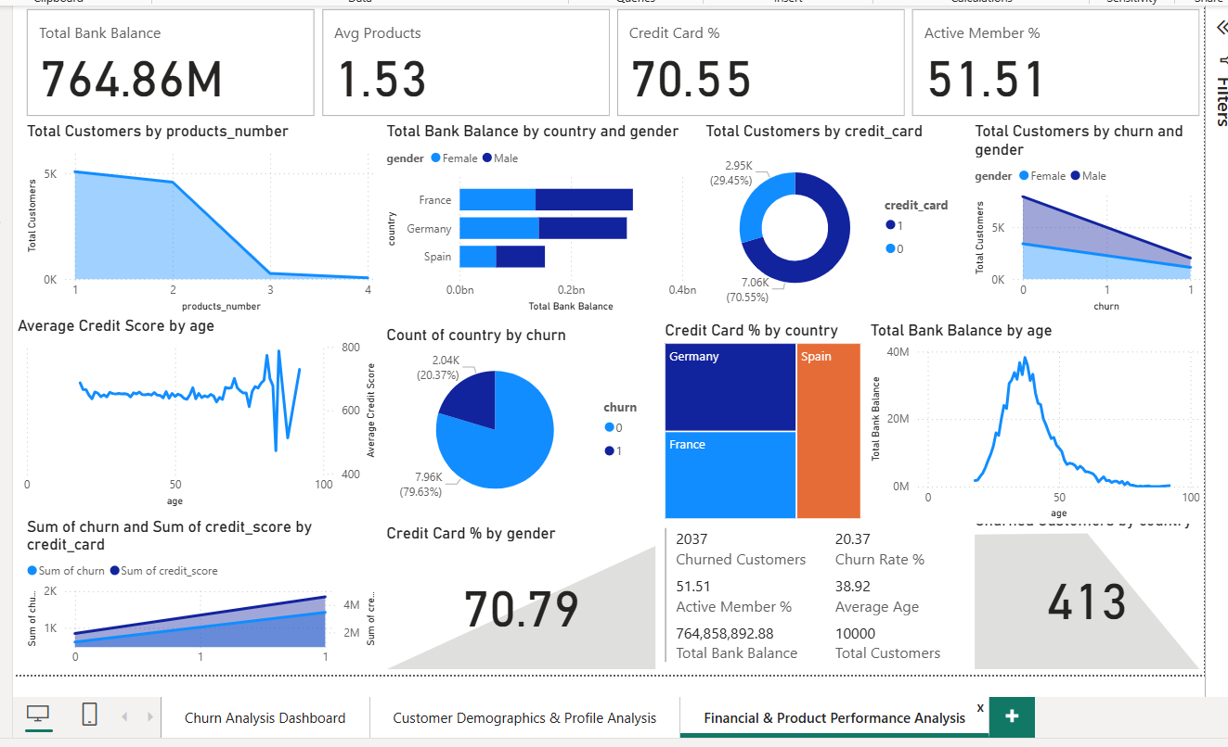
Dashboard Overview
The Financial & Product Performance Analysis Dashboard focuses on evaluating the bank’s financial strength, product usage, and customer engagement levels. It provides insights into how customers use bank products, how much value they generate, and how churn impacts overall revenue.
This dashboard helps management understand which products and customer segments drive the most financial value.
Key Performance Indicators (KPIs)
1. Total Bank Balance – 764.86M
This KPI represents the total deposits held by the bank across all customers.
It reflects the bank’s overall financial strength and liquidity position.
2. Average Products per Customer – 1.53
This indicates that customers, on average, use 1 to 2 bank products.
There is a strong opportunity for cross-selling additional products.
3. Credit Card Usage (%) – 70.55%
This KPI shows that over 70% of customers own a credit card.
Credit card adoption is high and plays a key role in customer engagement and credit profiling.
4. Active Member Percentage – 51.51%
Only about half of the customers are actively using bank services.
This suggests significant potential to increase engagement and reduce churn.
Visual Insights
5. Customers by Number of Products
This line chart shows customer distribution based on product ownership.
Key Insight:
- Most customers own 1 or 2 products
- Very few customers own 3 or more products
Increasing product penetration could improve customer loyalty.
6. Total Bank Balance by Country and Gender
This stacked bar chart shows balance distribution by geography and gender.
Key Insight:
- France contributes the highest total balance
- Male customers generally hold higher balances than females
- Germany and Spain contribute smaller but significant balances
7. Customers by Credit Card Ownership
This donut chart shows the proportion of customers with and without credit cards.
Key Insight:
- Majority of customers own a credit card
- Customers without credit cards represent a lower engagement segment
8. Customers by Churn and Gender
This area chart compares churned and non-churned customers by gender.
Key Insight:
- Both male and female customers experience churn
- Male customers show slightly higher churn impact
This highlights the importance of gender-inclusive retention strategies.
9. Average Credit Score by Age
This line chart shows how credit score varies with age.
Key Insight:
- Credit score remains relatively stable across most age groups
- Slight increase in credit score for older customers
- Some volatility at higher age ranges due to smaller sample size
10. Country Distribution by Churn
This pie chart shows churned vs non-churned customers.
Key Insight:
- Approximately 20% of customers have churned
- Around 80% remain active
This reinforces the churn rate observed in earlier dashboards.
11. Credit Card Percentage by Country
This treemap highlights credit card adoption by country.
Key Insight:
- Credit card usage is strong across all countries
- Germany and France show higher adoption than Spain
12. Total Bank Balance by Age
This line chart shows balance distribution across age groups.
Key Insight:
- Peak balances occur in the 40–50 age range
- Younger and older customers hold lower balances
This indicates that middle-aged customers are the most financially valuable.
13. Churn and Credit Score by Credit Card Ownership
This combined chart compares churn and credit score based on credit card status.
Key Insight:
- Customers with credit cards have higher credit scores
- Credit card holders show relatively lower churn
- Credit card ownership is associated with higher customer quality
14. Credit Card Percentage by Gender
This KPI shows similar credit card adoption between genders, indicating balanced usage.

